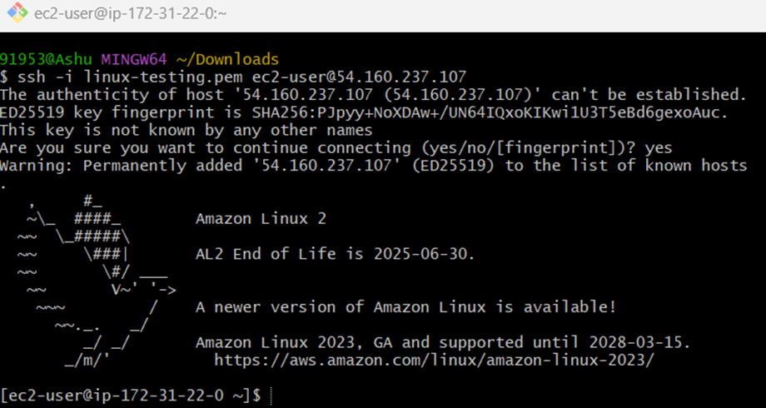

We have to install httpd In the terminal

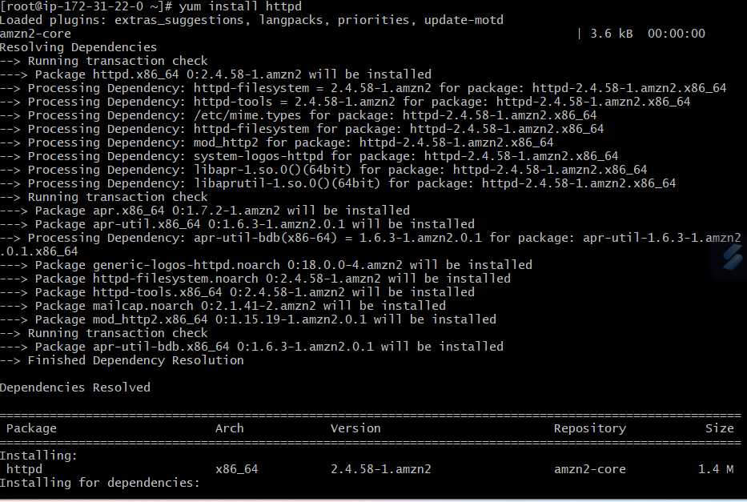

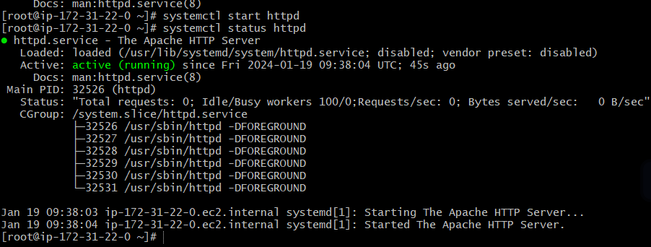

Our Apache server is started

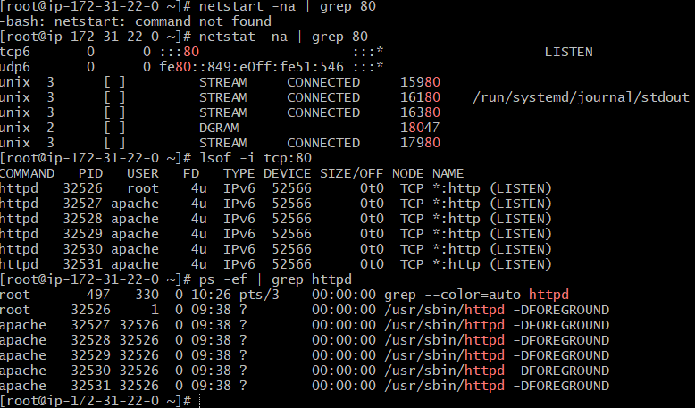

In these way we have to check our service are running or Not

This page is used to test the proper operation of the Apache HTTP server after it has been installed. If you can read this page, it means that the Apache HTTP server installed at this site is working properly

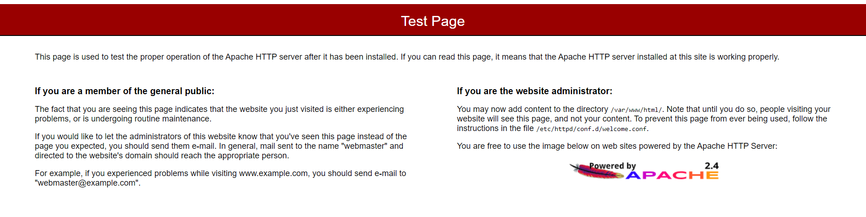 Default deployment location : /var/www/html in this files add the content in files only

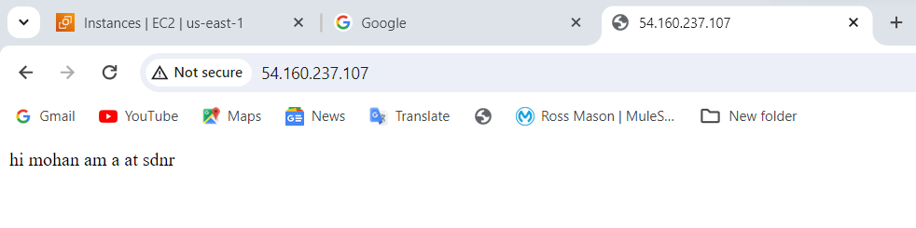

we have to install Nginx in shell and I will show the command then we will enter the command amazon linux

